Edward Miller Biography

Music Director

Unitarian Universalist Congregation at Shelter Rock

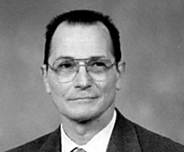
Born in 1943 in Astoria, NY, Edward grew up in Bayonne and later Cranford, NJ, where he attended the local high school. At Cranford High, he participated in a number of vocal groups and Music Club. After graduating in 1961, Edward attended Glassboro State College in NJ, where he majored in music education and voice. After graduating in 1965, he pursued his education further at Temple University in Philadelphia.
During his college years, Edward worked with a number of musical groups in the Philadelphia area, including the Men and Boys Choir of St. Marks Episcopal Church, the American Singers, the Oratorio Choir, and the Philadelphia Lyric Opera. He served as bass soloist with the choir of Temple Beth Torah, and also served as assistant manager of the New Jersey All-State Chorus.
Edward worked as music teacher in Vineland and Haddon Heights, NJ before moving to Long Island in 1972, where he began his 25 years of service at the East Rockaway Junior and Senior High Schools. During this time, Edward attended New York University, earning his Master of Arts degree in 1977. Later, he served as choirmaster and organist at St. John's Episcopal Church in New York City, and as music director at the Unitarian Universalist Congregation at Shelter Rock in Manhasset.
Edward Miller passed away suddenly in December 1997.

