**MELIKE & ÖZGÜR / TURKEY**

**PROSECUTED FOR CELEBRATING LGBTI RIGHTS**

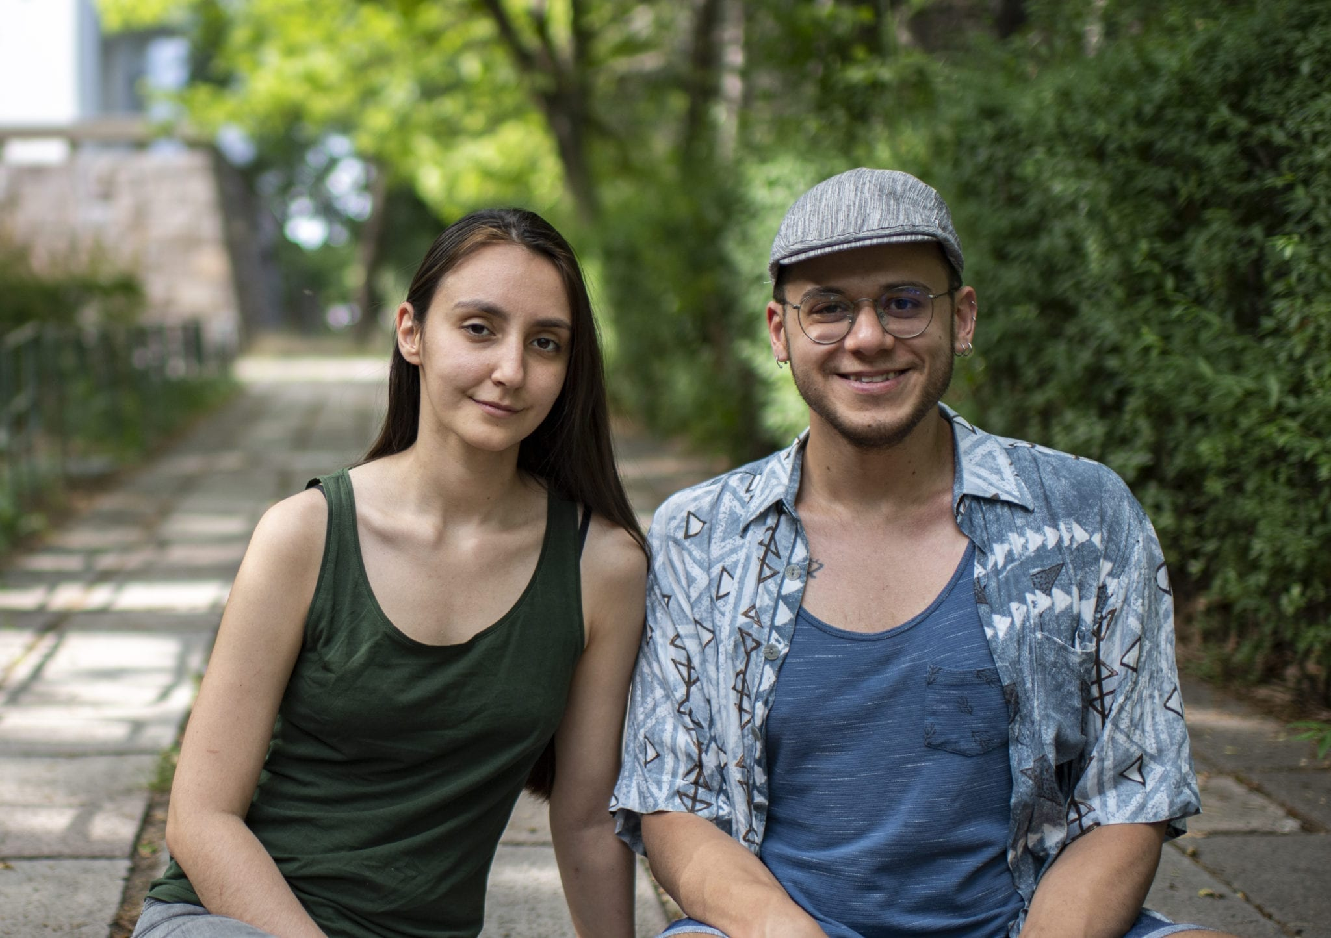

**take action**

**Tell Turkey to acquit protesters of all charges**

1) Write a letter to release Idris. The following case sheet will give you information and addresses. You can print and sign the sample letter at the end of this packet or copy it in your own handwriting or create your own letter using the information in the sample letter and on the case sheet.

2) Write a solidarity note to the METU LGBTI+ group ([case sheet](https://write.amnestyusa.org/wp-content/uploads/2020/09/Turkey-Case-Sheet-w-report.pdf))

3) [Sign the online petition for Melike & Özgür](https://act.amnestyusa.org/page/67952/action/1?ea.tracking.id=8p2qt986" \t "_blank)

4) [Sign the online petition (once) for all seven cases](https://act.amnestyusa.org/page/67963/petition/1?ea.tracking.id=8p2qt986" \t "_blank)

5) [Report your letters](https://write.amnestyusa.org/impact/" \t "_blank)

From day one, biology students Melike Balkan and Özgür Gür dedicated themselves to defending lesbian, gay, bi-sexual, transgender and intersex (LGBTI+) rights at their university. As members of the LGBTI+ Solidarity Group, they have organized campus Pride marches successfully for years. But in May 2019, the university banned the planned march and called the police to disperse the peaceful sit-in. Despite simply exercising their right to peaceful protest, 18 students and an academic are now on trial.