**FAMILIES IN DETENTION / usa**

**DETAINED BY ICE AFTER FLEEING FROM DANGER**

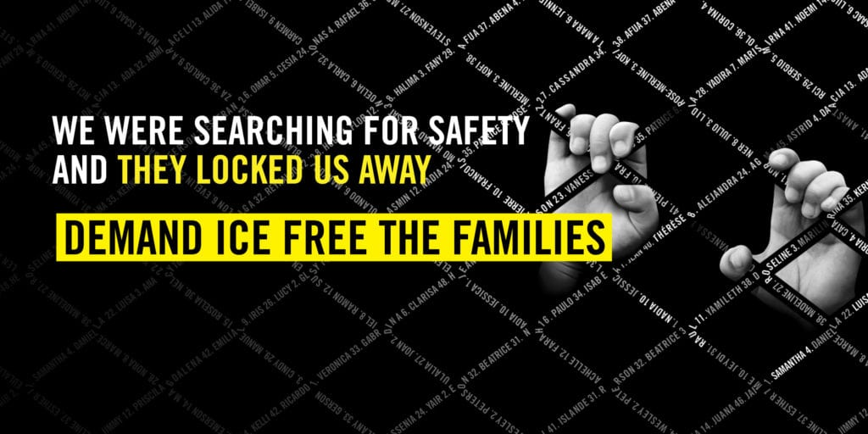

**take action**

**Tell ICE to release all families in detention**

There are links in numbers 1-5. Hover over the underlined text while holding down CTRL. Then click to open the link.

1) Write a letter for the families in detention ([case sheet](https://write.amnestyusa.org/wp-content/uploads/2020/11/USA-Families-in-Detention-Case-Sheet-w-report.pdf) / [sample letter](https://write.amnestyusa.org/wp-content/uploads/2020/11/USA-Families-in-Detention-Case-Sheet-w-report.pdf))

2) Write a solidarity note to the families ([case sheet](https://write.amnestyusa.org/wp-content/uploads/2020/11/USA-Families-in-Detention-Case-Sheet-w-report.pdf))

3) [Sign the online petition for the families](https://act.amnestyusa.org/page/67885/action/1?ea.tracking.id=8p2qt986)

4) [Sign the online petition (once) for all seven cases](https://act.amnestyusa.org/page/67963/petition/1?ea.tracking.id=8p2qt986)

5) [Report your letters](https://write.amnestyusa.org/impact/)

With confirmed cases of COVID-19 in family detention facilities, families face grave complications and even death if they contract the virus. There are credible, consistent, and disturbing accounts by families of dangerous conditions that put all families, facility staff, and surrounding communities at risk. These families came to the United States seeking protection from violence and persecution. They must be able to pursue the right to seek asylum in safety.