**NASSIMA AL-SADA**

**SAUDIA ARABIA**

**JAILED FOR DEFENDING WOMEN’S RIGHTS**

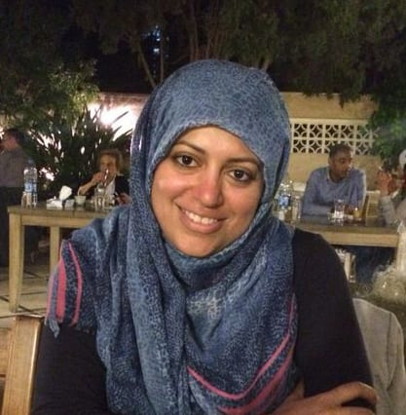

**take action**

**Tell Saudi Arabia to free Nassima now**

1) Write a letter Nassima. The following case sheet will give you information and addresses. You can print and sign the sample letter at the end of this packet or copy it in your own handwriting or create your own letter using the information in the sample letter and on the case sheet.

2) Write a solidarity note to Nassima ([case sheet](https://write.amnestyusa.org/wp-content/uploads/2020/09/Saudi-Arabia-Case-Sheet-w-report.pdf))

3) [Sign the online petition for Nassima](https://act.amnestyusa.org/page/67953/action/1?ea.tracking.id=8p2qt986" \t "_blank)

4) [Sign the online petition (once) for all seven cases](https://act.amnestyusa.org/page/67963/petition/1?ea.tracking.id=8p2qt986" \t "_blank)

5) [Report your letters](https://write.amnestyusa.org/impact/" \t "_blank)

For much of her life, Nassima al-Sada has campaigned for women’s rights in Saudi Arabia. Now, she’s lost her own. She’s one of 13 prominent female activists prosecuted for demanding women’s right to drive and the right to carry out their daily business without the permission of a male ”guardian”. Since her arrest in July 2018, she has been locked up, enduring ill-treatment and solitary confinement – all for her peaceful efforts to defend women’s rights.