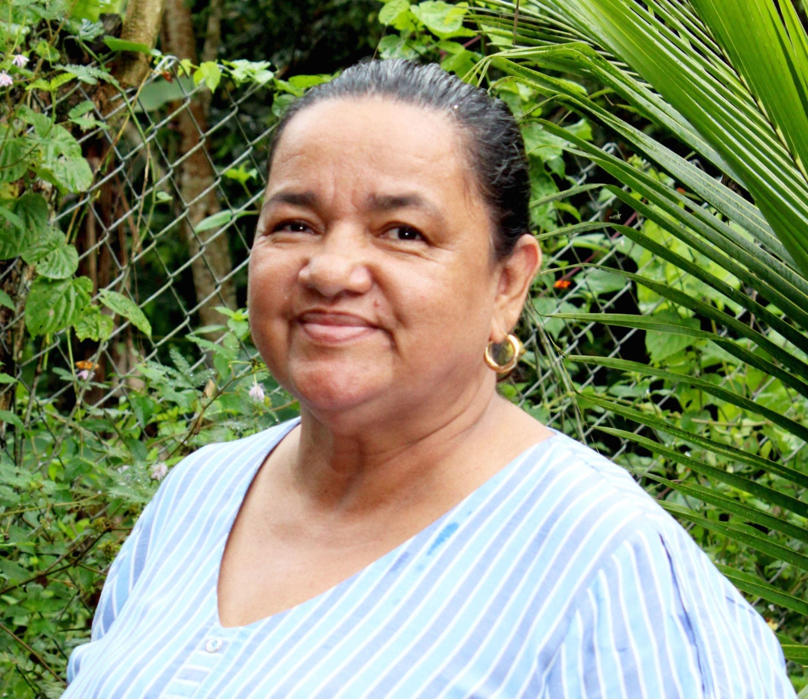

Born in the heart of the Colombian Amazon, Jani Silva has dedicated her life to defending the trees and land that are everyone’s lifeblood. From the age of 16, she’s been standing with the campesino farmers of Putumayo, a region nestled in the south of the country and brimming with unique biodiversity. Her work has pitted her against forces greedy for that land’s oil wealth. Threatened and intimidated by unknown aggressors, her life is in danger.

**take action**

**Demand protection for Jani**

There are links in numbers 1-5. Hover over the underlined text while holding down CTRL. Then click to open the link.

1) Write a letter for Jani ([case sheet](https://write.amnestyusa.org/wp-content/uploads/2020/11/Colombia-Case-Sheet-w-report.pdf) / [sample letter)](https://write.amnestyusa.org/wp-content/uploads/2020/11/COLOMBIA-Jani-Silva-letter-to-target-APPROVED.docx)

2) Write a solidarity note to Jani ([case sheet](https://write.amnestyusa.org/wp-content/uploads/2020/11/Colombia-Case-Sheet-w-report.pdf))

3) [Sign the online petition for Jani](https://act.amnestyusa.org/page/67950/action/1?ea.tracking.id=8p2qt986" \t "_blank)

4) [Sign the online petition (once) for all seven cases](https://act.amnestyusa.org/page/67963/petition/1?ea.tracking.id=8p2qt986" \t "_blank)

5) [Report your letters](http://write.amnestyusa.org/impact/" \t "_blank)

**JANI SILVA / COLOMBIA**

**THREATENED FOR DEFENDING THE AMAZON**